Final practical work -sheet

**Experiment Title****.Non-inverting amplifier.**

**Student Name: Smita Shinde UID: 20BCS4643**

**Branch: CSE (IOT) Section/Group: A**

**Semester: 1 Date of Performance:01/14/21**

**Subject Name: BEEE Lab Subject Code: 20ELP-112**

1 Aim:To measure gain of non- inverting operational amplifier

2. Apparatus:

|  |  |  |  |
| --- | --- | --- | --- |
| Sr. no. | Equipment name | Specification and range | Quantity in no. |
| 1. | Op-amp IC | IC 741 op-amp | 1 |
| 2. | CRO | 0-230V,30MHz | 1 |
| 3. | CRO probes | **-----------** | 2 |
| 4. | Resistor | 1 ohm, 10 ohm | 1,1 |
| 5. | Digital multi meter | **----------** | 1 |
| 6. | Function generator | 1 to 10 Mhz | 1 |
| 7. | Bread board | **----------** | **--------** |
| 8. | Connecting wire | As per requirement | **--------** |

**3. Circuit Diagram:**

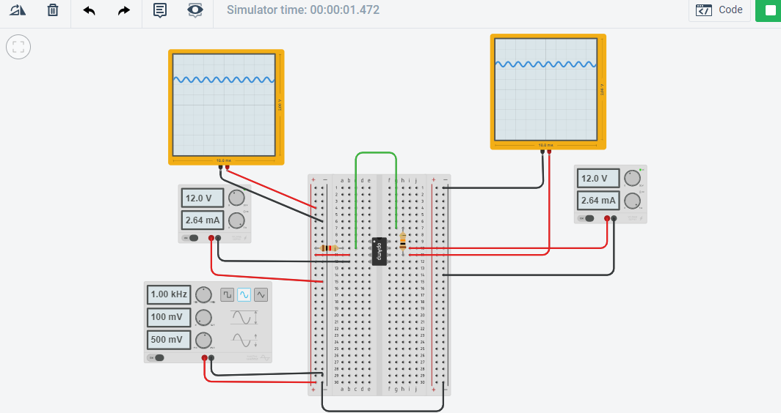

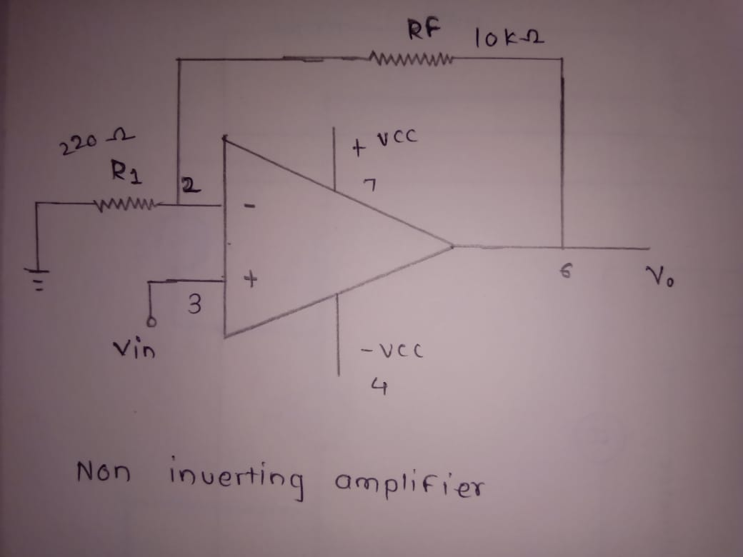

4. Steps for experiment:

***Non-inverting Amplifier:***

Step.1. Connect the circuit as shown in the fig. 1.

Step.2. Connect supply voltage to I/P.

Step.3. Note the values of RF & R1.

Step.4. Note VIN & VOUT with the digital multimeter.

Step.5. Repeat steps 2 & 3 for different values of RF &R1

5. Calculations/Theorems /Formulas used etc.

Non-inverting Amplifier: An amplifier whose O/P is in phase with the input. It can amplify ac and dc signals. Its gain depends upon the values of feedback resistance (RF) and input resistance

**VO = VIN (1+RF/Rin)**

6. Observations/Discussions:

Observe the output waveform from CRO. A non-inverted and amplified waveform will be observed.

Measure the input and output voltage from the input and output waveform in the CRO.

Calculate

V=(1+R2/R1)Vin

Compare the theoretical voltage gain from the above equation with the experimental value obtained by dividing output voltage by input voltages observed.

Observe outputs of the inverting amplifier circuit using different input waveforms.

7. Percentage error (if any or applicable):

1.Due to internal resistance of multi-meter.

2.Due to interruption of power supply.

3.Due to wrong connection of circuit.

8. Result/Output/Writing Summary:

In non-**inverting** amplifier O/P is in **phase** with I/P with I/P. The waveform for non-inverting and amplifier is shown in figure below:

9. Graphs (If Any): Image /Soft copy of graph paper to be attached here

Non-inverting amplifier curve

***Input:-***

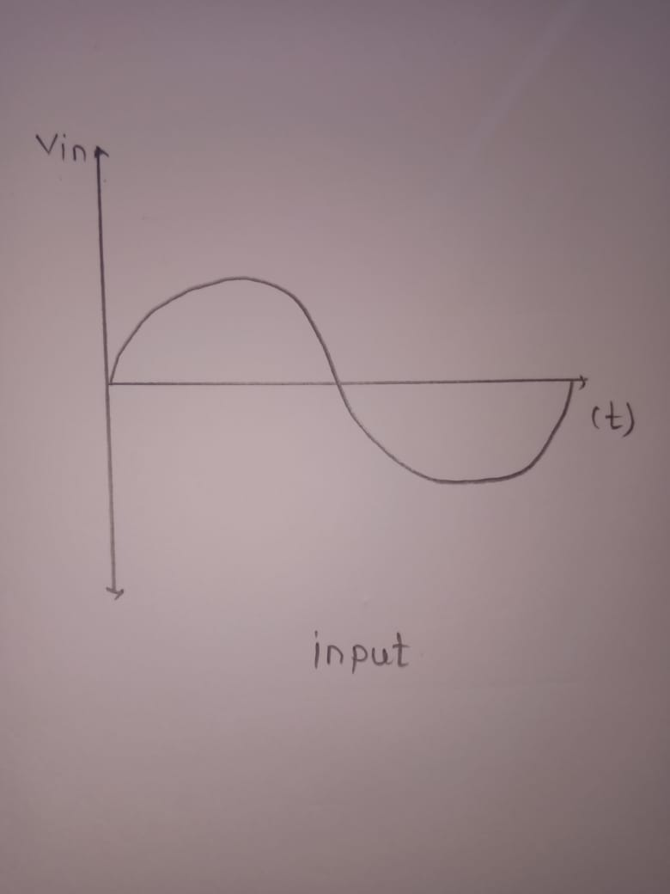

***Output***

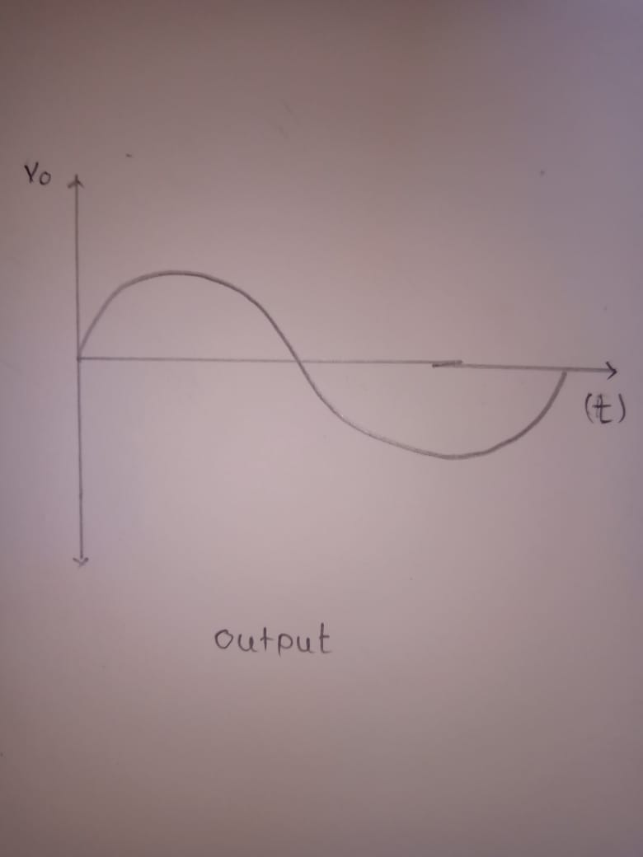

Learning outcomes (What I have learnt):

1.I have the learnt the concept of non-inverting amplifier.

2. .I have the learnt the understand the working of non-inverting amplifier.

3. .I have the learnt to determine the gain of non-inverting amplifier.

**Evaluation Grid:**

|  |  |  |  |
| --- | --- | --- | --- |
| Sr. No. | Parameters | Marks Obtained | Maximum Marks |
| 1. | Worksheet completion including writing learning objectives/Outcomes.(To be  submitted at the end of the day). |  | 10 |
| 2. | Post Lab Quiz Result. |  | 5 |
| 3. | Student Engagement in Simulation/Demonstration/Performance and Controls/Pre-Lab Questions. |  | 5 |
|  | Signature of Faculty (with Date): | Total Marks Obtained: |  |